Objective Questions

1. **List the different dtypes of columns in table “ball_by_ball” (using information schema)**

Ans 1 There are 10 different types of columns in table “ball_by_ball” and their

data types are also shown in below screen shot.

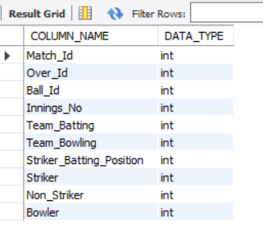

1. **What is the total number of run scored in 1st season by RCB (bonus : also include the extra runs using the extra runs table)**

**Ans:** Total number of run scored in 1st season by RCB is 1983

**Reference:** ball_by_ball, batsman_scored, matches, season, wicket_taken



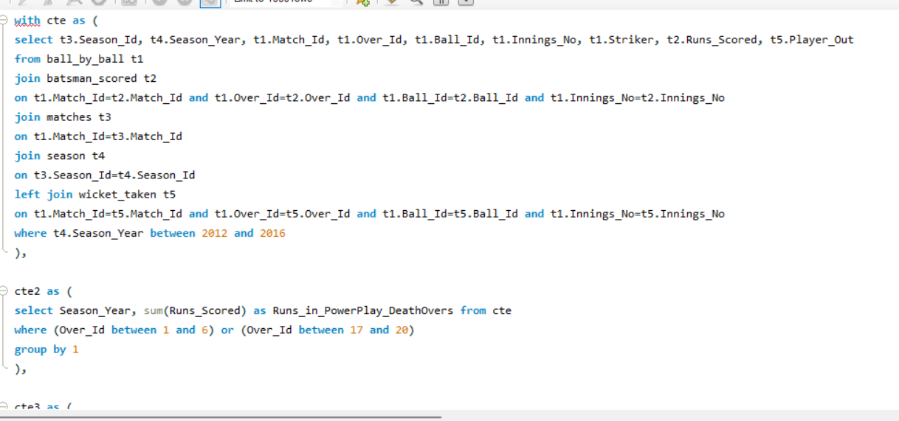

1. **How many players were more than age of 25 during season 2?**

**Ans:** There are 93 players who were more than 25 years old.

**Reference:** matches, player_match, player, season,



**Query:**

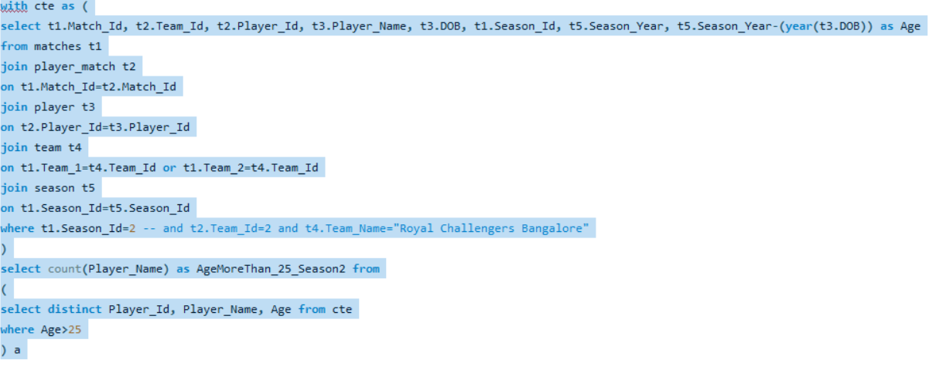

1. **How many matches did RCB win in season 1?**

**Ans**

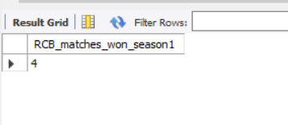

**Query:**

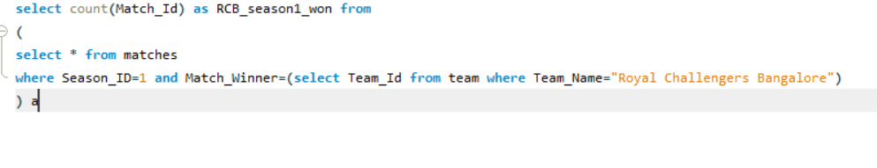

1. **List top 10 players according to their strike rate in last 4 seasons**

**Ans:** here are the list of top 10 players according to their strike rate in last 4 seasons.

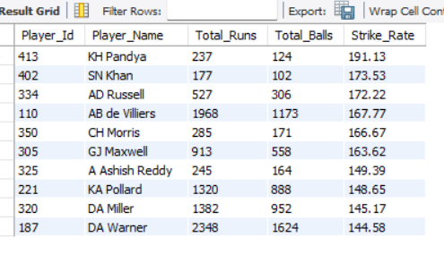

**Reference:** ball_by_ball, batsman_scored, season, matches

**Query:** 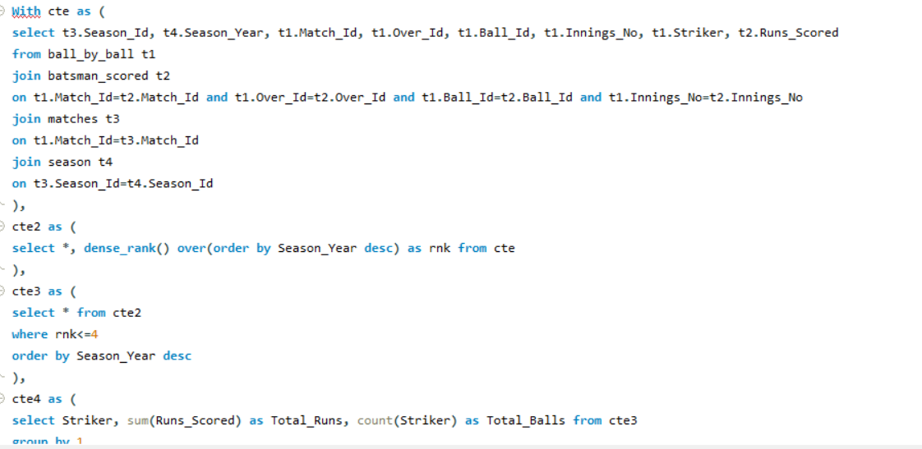

1. **What is the average runs scored by each batsman considering all the seasons?**

**Ans:** Below table is showing the average runs scored by each batsman in all seasons.

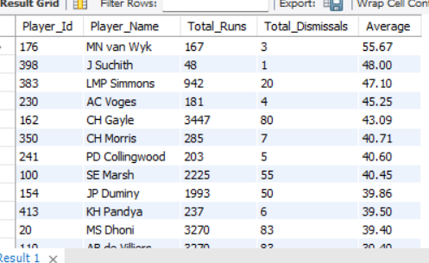

**Reference:** ball_by_ball, batsman_scored, matches, season

**Query:**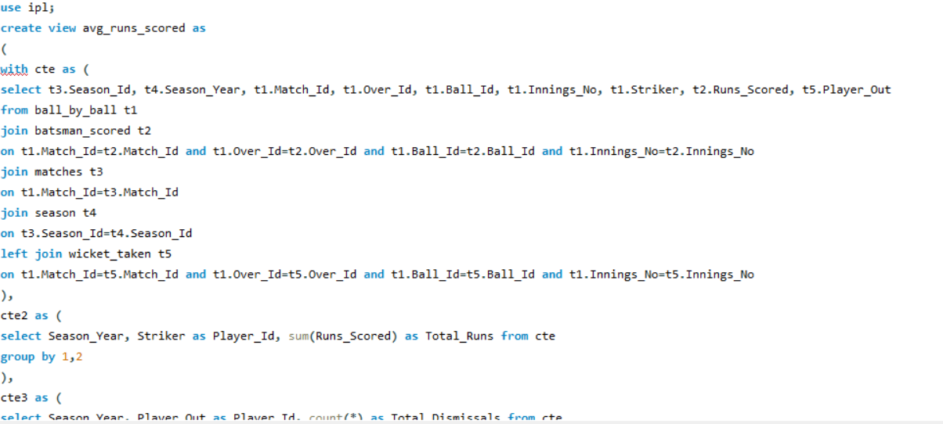

1. **What are the average wickets taken by each bowler considering all the seasons?**

**Ans:** Below table is showing average wickets taken by each bowler in every seasons.

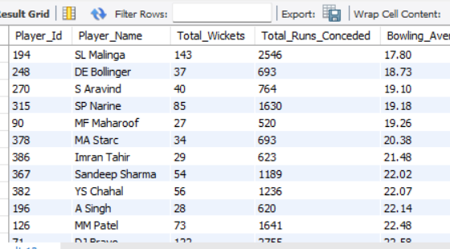

**Reference:** ball_by_ball,

Wicket_taken, matches, season, out_type, extra_runs,extra_type

**Query:** 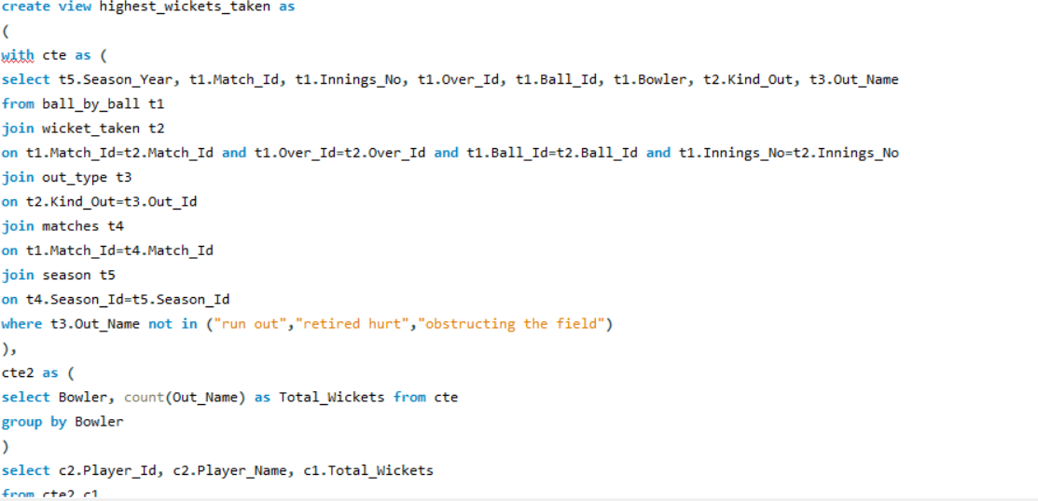

1. **List all the players who have average runs scored greater than overall average and who have taken wickets greater than overall average**

**Ans:** below table is showing the list of all the players who have average runs scored greater than overall average and who have taken wickets greater than overall average

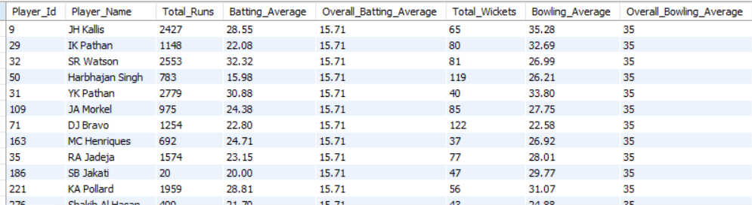

**Reference:** player, Total_player_avg, runs_conceded, highest_wicket_taken,

**Query:** 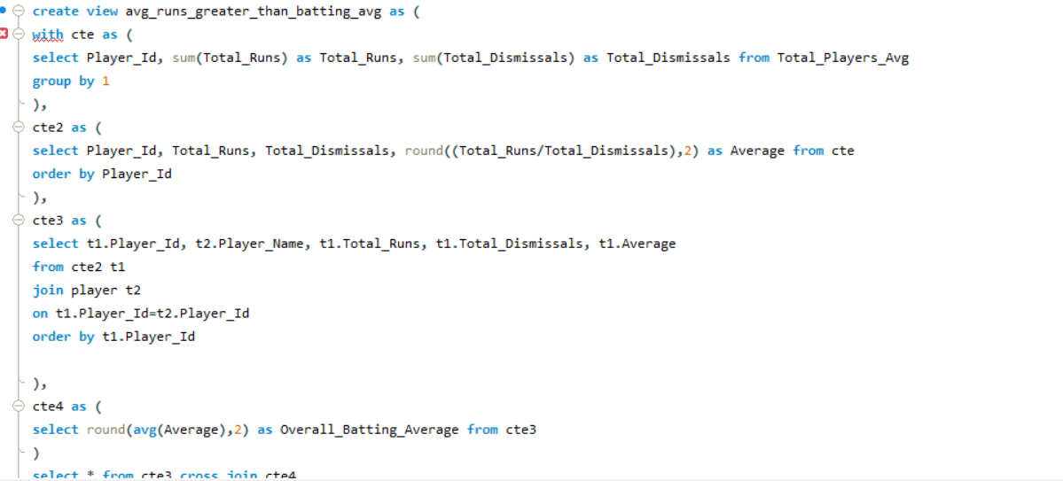

1. **Create a table rcb_record table that shows wins and losses of RCB in an individual venue.**

**Ans:** Below table is showing wins and losses of RCB in individual venue.

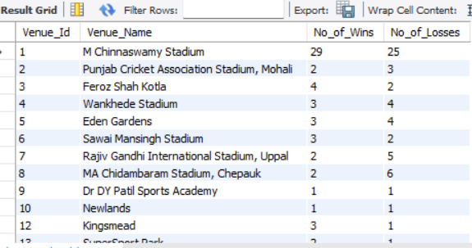

**Reference:** matches, venue

**Query:** 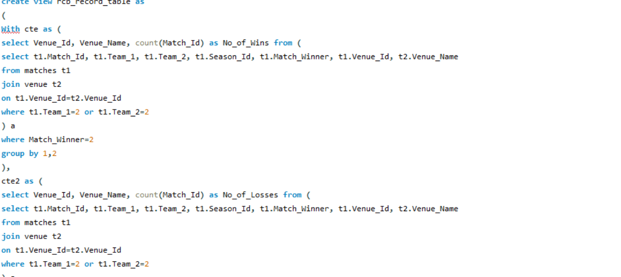

1. **What is the impact of bowling style on wickets taken.**

**Ans:** By the table we can say that a bowler can take highest number of wickets by playing Right arm fast medium bowling style.

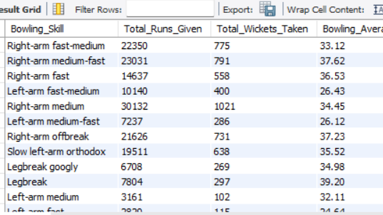

**Reference:** ball_by_ball, players, runs_conceded, bowling_style, highest_wicket_taken

**Query:** 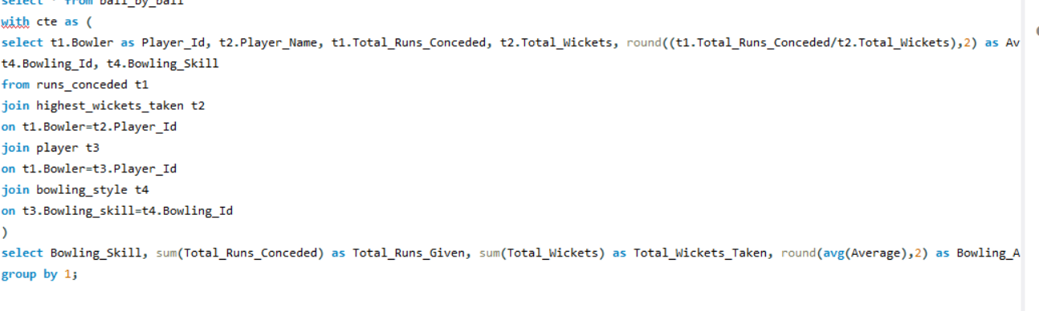

1. **Write the sql query to provide a status of whether the performance of the team better than the previous year performance on the basis of number of runs scored by the team in the season and number of wickets taken**

**Ans:** Below table is showing the performance of each team in every year.

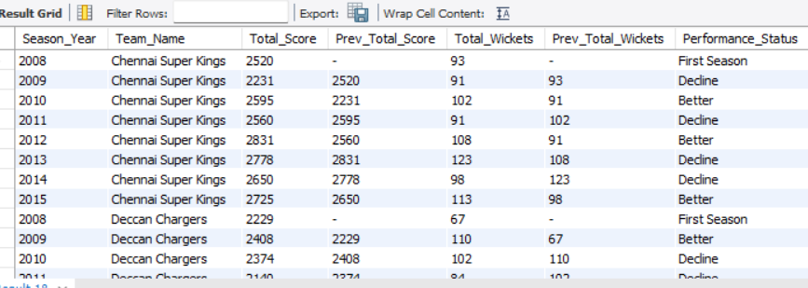

**Reference:** matches, team, toss_decision, wicket_taken, out_type, season

**Query:**

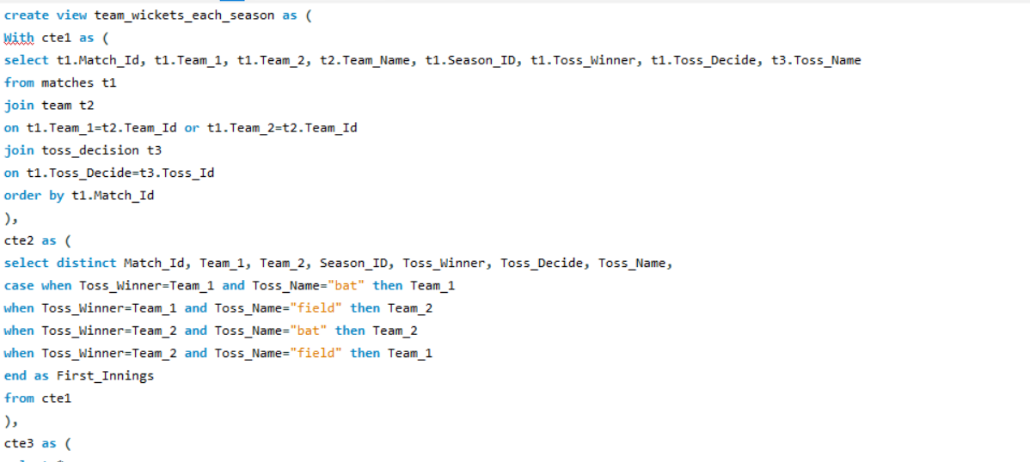

**12.Can you derive more KPIs for the team strategy if possible?**

**Ans:** The KPIs we can consider are :

* Win percentage of each team,
* numbers of catches taken by each player,
* total runs conceded by each player,
* total wickets taken by each player
* bowling average

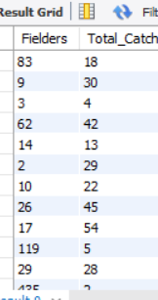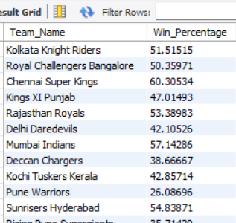

**Reference:** team, matches, wicket_taken,player, batsman_scored, ball_by_ball, extra_runs

**Query:**

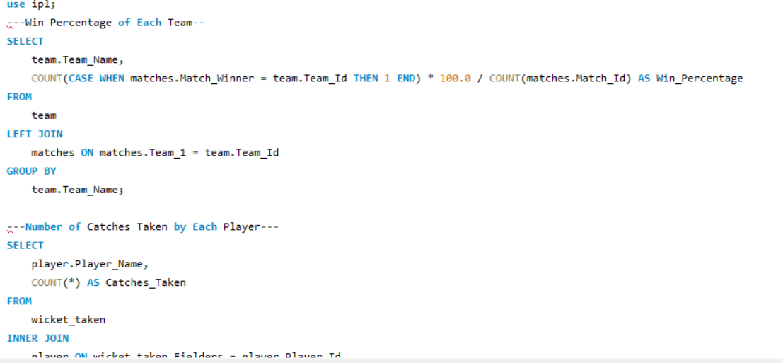

**13.Using SQL, write a query to find out average wickets taken by each bowler in each venue. Also rank the gender according to the average value.**

**Ans:** Below table is showing the rank of bowlers according to average wickets taken by them.

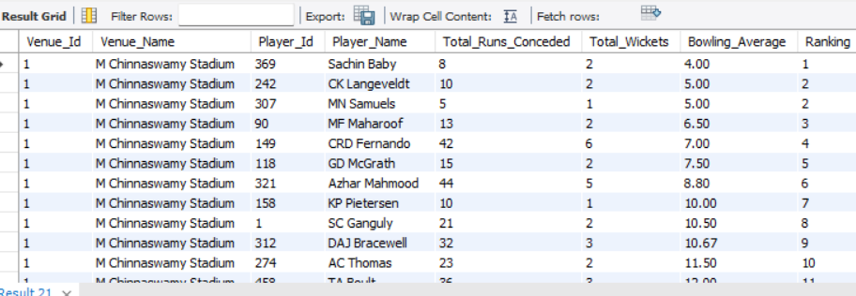

**Reference:** ball_by_ball, wicket_taken, out_type, matches, season, venue, player, batsman_scored, extra_runs, extra_type.

**Query:**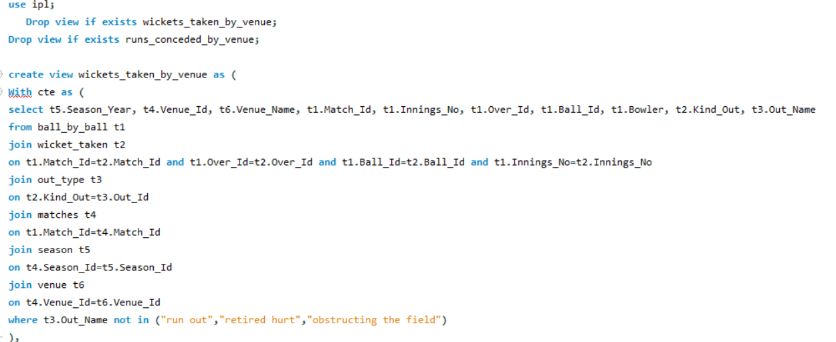

**14.Which of the given players have consistently performed well in past seasons? (will you use any visualization to solve the problem)**

**Ans:** As we can see G.Gambhir, MS Dhoni, RG Sharma, RV Uthappa, S Dhawan, SK Raina and Virat Kohli are the top performers in past seasons.

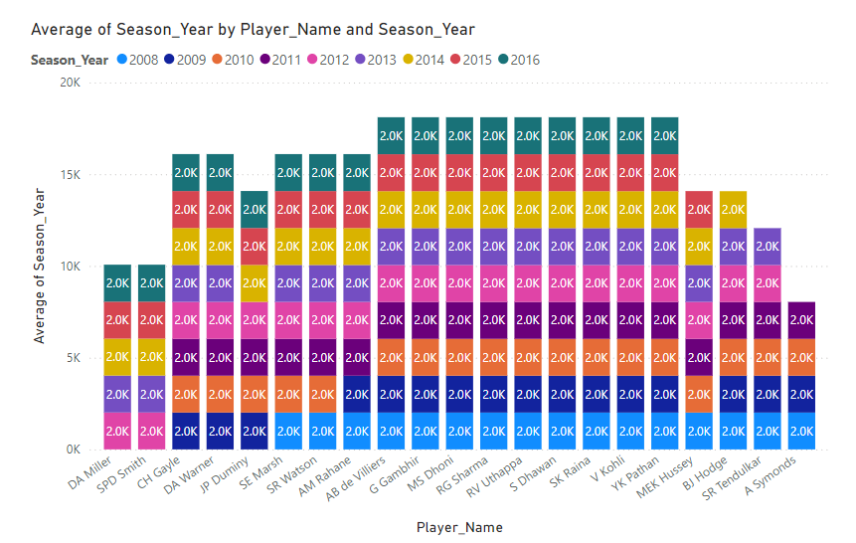

**Reference:** season, player, Total_Players_Avg

**Query:**

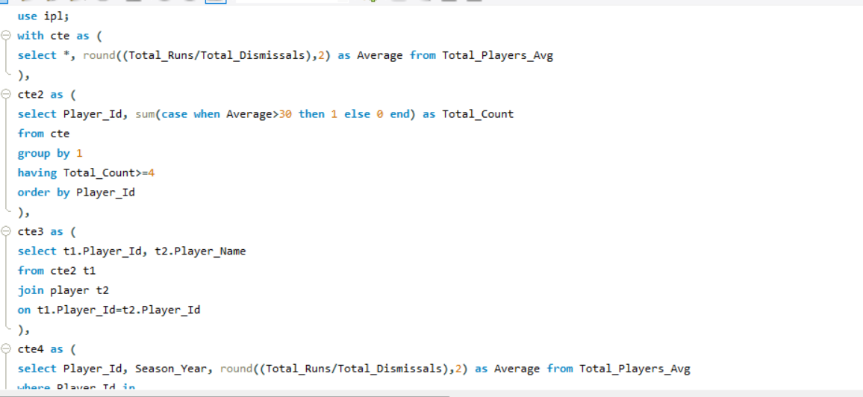

1. **Are there players whose performance is more suited to specific venues or conditions? (how would you present this using charts?)**

**Ans**

* Andrew Symonds seems to perform exceptionally well at the M. Chinnaswamy Stadium, where he has the highest run tally (1759 runs) compared to other venues. This suggests that his performance is particularly suited to this venue.
* AB de Villiers has a significant number of runs at the M.A. Chidambaram Stadium (1302 runs). This indicates that he is likely to perform well in this venue, making it one of his preferred grounds.
* Rahane has scored 1235 runs at the Wankhede Stadium, highlighting his strong performance in this venue. This suggests that he is better suited to playing in Mumbai conditions.
* Warner has a good record at Eden Gardens with 1149 runs. His consistent performance at this venue suggests he is well-suited to the conditions in Kolkata.
* Kallis has also shown a preference for Rajiv Gandhi International Stadium, where he scored 933 runs, indicating that this venue is favorable for his style of play.

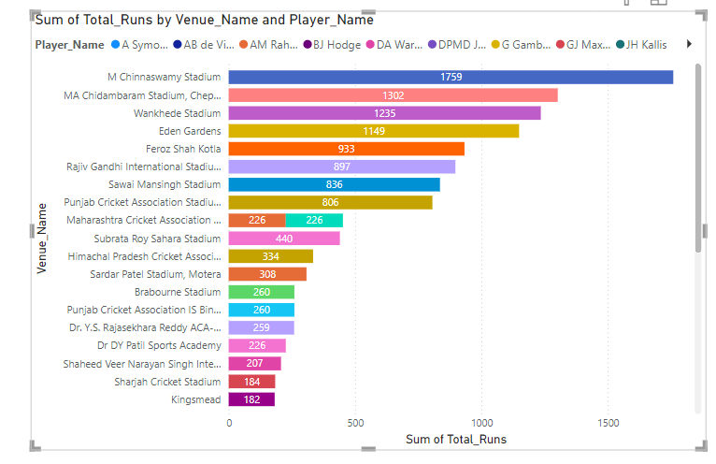

**Reference:** ball_by_ball, batsman_scored, venue, matches, season

**Query:**

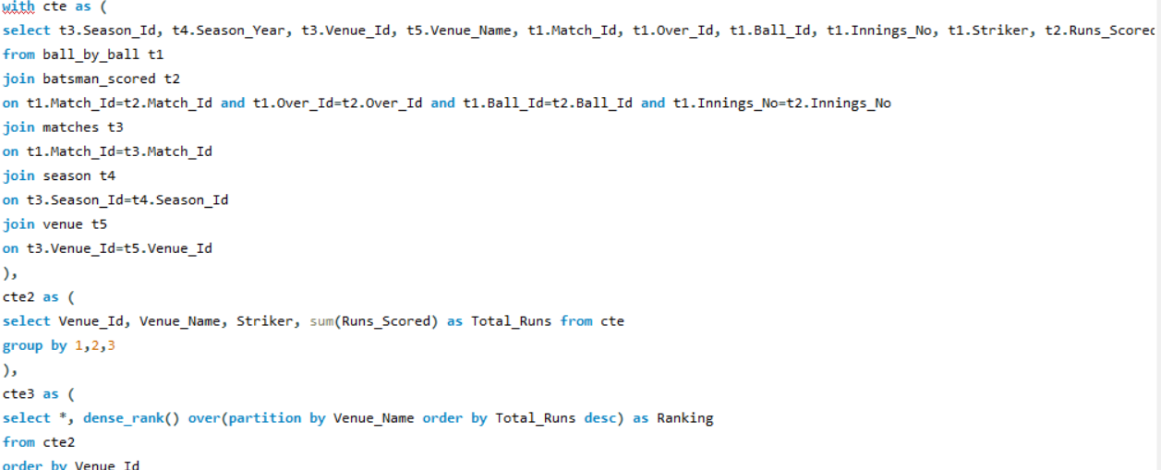

Subjective Questions

1. **How does toss decision have affected the result of the match ? (which visualisations could be used to better present your answer) And is the impact limited to only specific venues?**

**Ans:** At most venues, winning the toss seems to provide a slight advantage. For instance, venues like Barabati Stadium and Brabourne Stadium show a high winning percentage for teams that won the toss (71.43% and 63.64% respectively).

* + - Conversely, some venues such as Himachal Pradesh Cricket Association Stadium and Kingsmead have significantly lower win percentages for teams that won the toss (55.56% and 13.57% respectively).
    - The impact of winning the toss varies significantly across different venues.
    - Some venues exhibit a strong correlation between winning the toss and winning the match, while others show little to no correlation.
    - This suggests that while toss decisions can influence match outcomes, other factors such as pitch conditions, team performance,
    - and match strategies are equally, if not more, important.

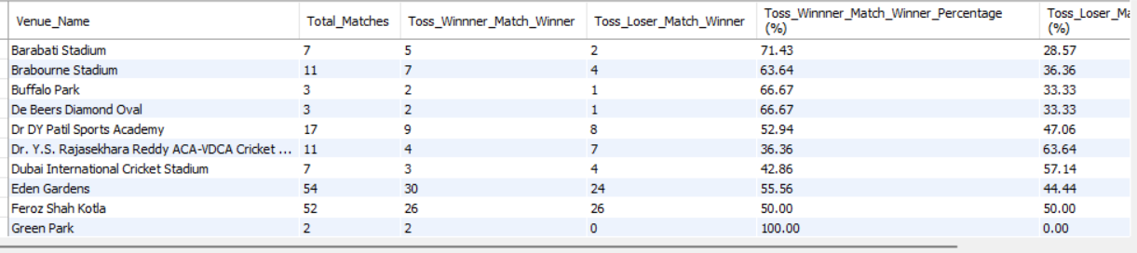

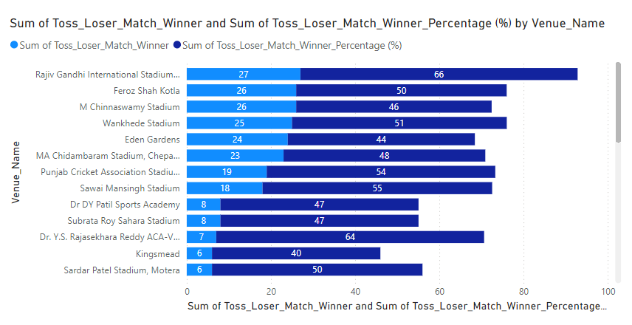

**Recommendation:** winning the toss is obviously a boost of confidence to the team. And it can affect the winning percentage of

The team. Still the performance of the team members will play a vital role in winning the match.

**2.Suggest some of the players who would be best fit for the team?**

**Ans:** We have the table for potential player names with their strike rate, overall average runs scored and overall average wickets taken.

Now we have to determine the threshold of each metrics. We have to filter players who have an average runs scored greater than the overall average and who have taken more wickets than the overall average.. the selection criteria should be like below pointers.

* **Batsmen**: High total runs and high matches played.
* **Bowlers**: High average wickets taken and acceptable economy rate.

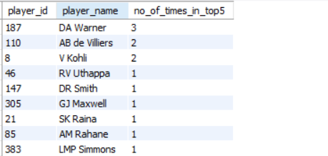

**Query:**

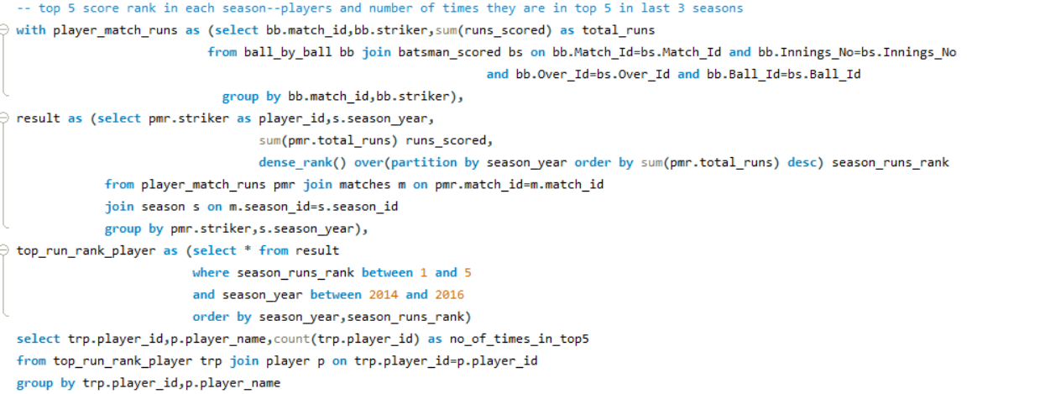

**Recommendation**: By analyzing the table I can say that Harbjan Singh, SL Malinga, R Ashwin will be the best fir for team. Because Pandya has highest strike rate and the rest mentioned players are good bowler.

1. **What are some of parameters that should be focused while selecting the players?**

**Ans:**  the below images are show the performances of theplayers in the past IPL seasons. The mentioned parameters should be mainly focused while selecting the players.

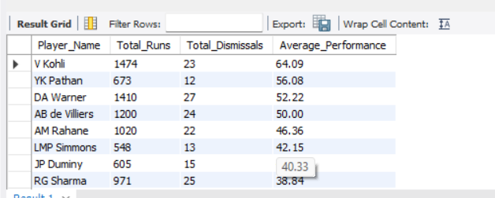

**Query:**

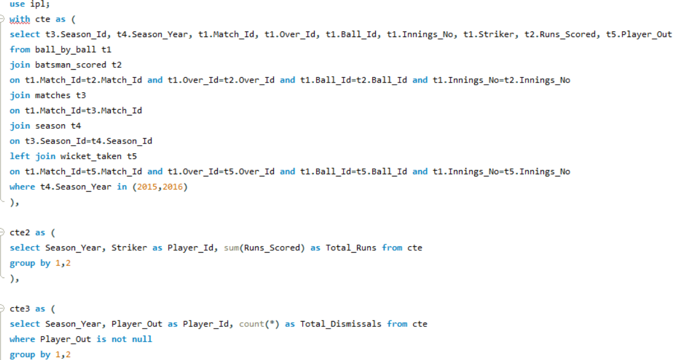

High Strike Rate and Lower Cost:

* Impact on Match Outcome: A high strike rate means that the player can score runs quickly, which is essential in T20 cricket where every ball counts. Players who can accelerate the scoring rate without consuming too many balls are game-changers.
* Budget Efficiency: With the IPL's salary cap, teams need to maximize their return on investment. A player with a high strike rate at a lower cost provides exceptional value, allowing teams to strengthen other areas of the squad without overspending.
* Depth in the Squad: Cost-effective players with high strike rates enable teams to create a deeper squad, ensuring a strong bench and flexibility in player selection throughout the season.

2. Death Over Performance:

* Critical Overs: The death overs (typically the last 4-5 overs of an innings) are crucial in a T20 match. Teams can either significantly boost their total or restrict the opposition during this phase. Players who excel in death-over batting or bowling are vital.
* Bowling in Pressure Situations: Bowlers who can deliver yorkers, slower balls, and other variations effectively during the death overs can prevent the opposition from scoring freely, which is often the difference between winning and losing.
* Finishing the Innings: Batsmen who can accelerate in the death overs can add crucial runs to the team's total, turning a par score into a winning one.

3. Fitness:

* Consistency: Fit players are more likely to stay injury-free throughout the tournament, providing consistent performances without the need for frequent replacements.
* Fielding Excellence: Fitness directly impacts a player's fielding abilities. Agile and fit players save crucial runs, take difficult catches, and make game-changing run-outs, which can often be the difference in close matches.
* Endurance: The IPL is a grueling tournament with back-to-back matches. Fitter players can maintain high performance levels throughout the season, even under the physical demands of the league.

**Recommendation:** Strike rate, Total runs scored, Average wickets taken, Death over performance, IPL performance, Versatility, Allrounder ,Wicket Keeper, Cost, Fitness are the points that we can keep in mind while selecting the players.

1. **Which players offer versatility in their skills and can contribute effectively with both bat and ball? (can you visualize the data for the same)**

**Ans:** The players mentioned in the chart offer versatility in their skill



**Query:**

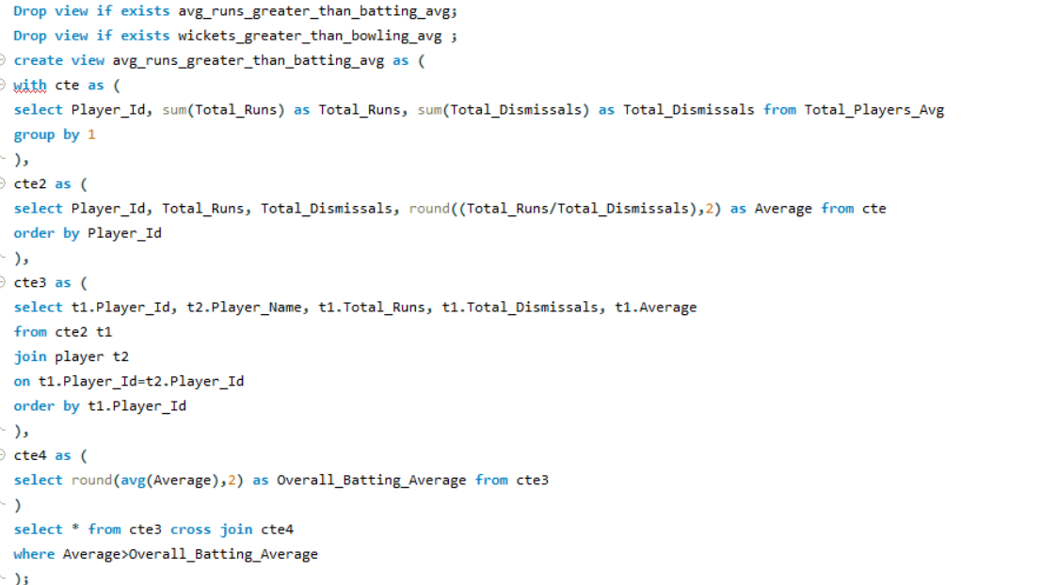

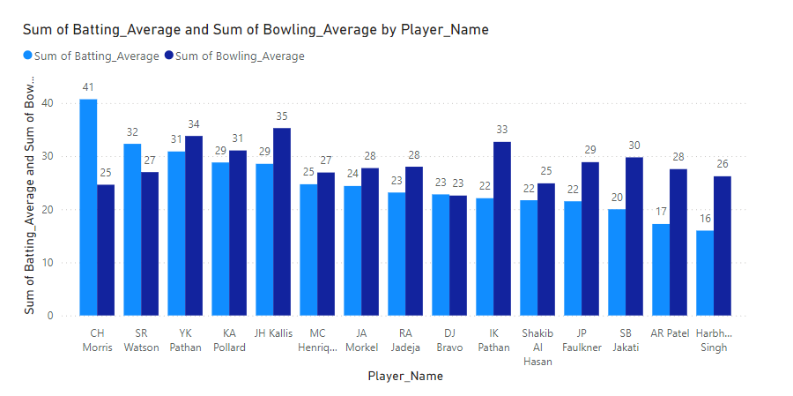

* **CH Morris** shows a high batting average (41) combined with a decent bowling average (25), indicating strong all-round performance.
* **SR Watson**, **YK Pathan**, and **KA Pollard** also demonstrate a balance between batting and bowling abilities, with both their averages indicating versatility and consistent contributions in both departments.
* Players like **DJ Bravo** and **Shakib Al Hasan** have relatively balanced performances, making them reliable options for both batting and bowling.

**Recommendation:**

The analysis suggests that **CH Morris**, **SR Watson**, **YK Pathan**, and **KA Pollard** are particularly versatile, offering significant value in both batting and bowling. This versatility makes them valuable players in the team, as they contribute effectively in multiple roles.

1. **Are there players whose presence positively influences the morale and performance of the team? (justify your answer using visualisation)**

**Ans:** 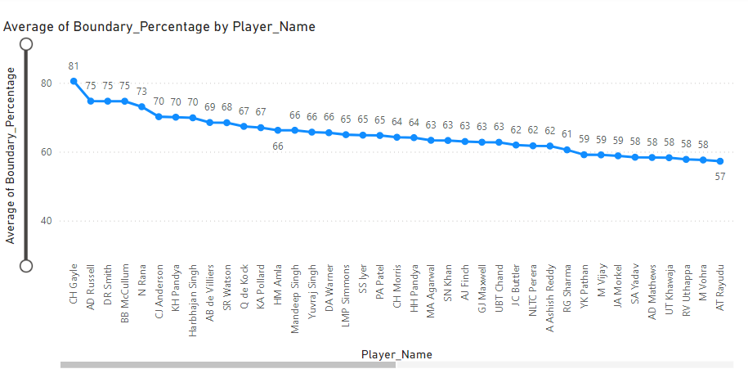

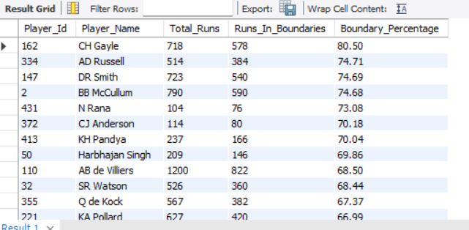

**Query:**

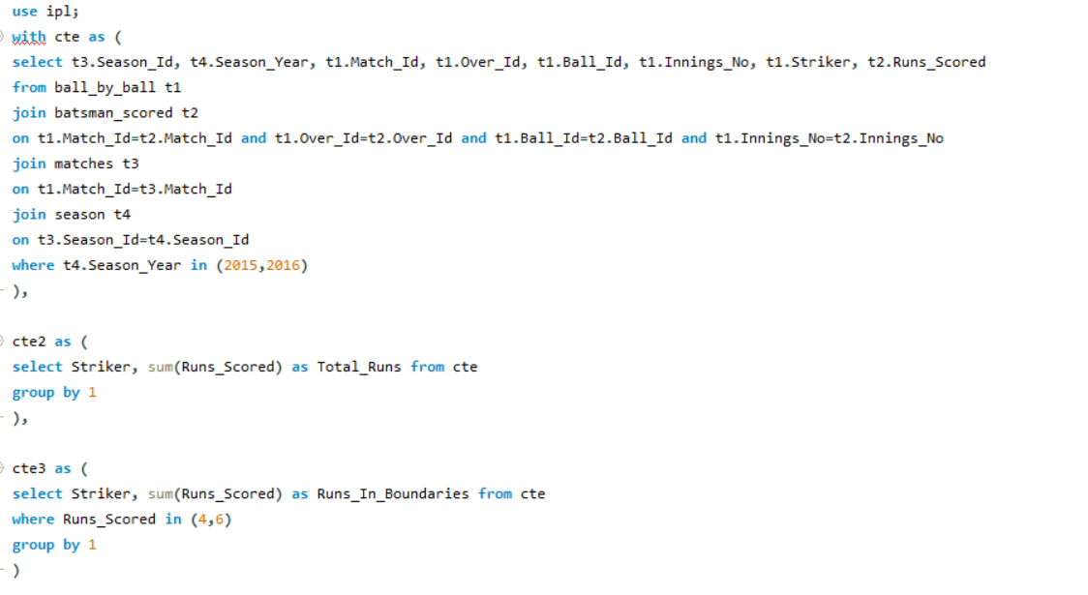

**Top Performers**:

* **DA Warner (81%)**, **AB de Villiers (75%)**, and **DA Miller (73%)** are among the top in boundary percentage. These players are likely to boost team morale as they can change the game’s momentum with quick runs.

**Impact on Morale**:

* Players with high boundary percentages are crowd favourites and often have a significant psychological impact on both teams. When such players are at the crease, it uplifts the team's spirit and instils confidence that they can chase or set high totals.

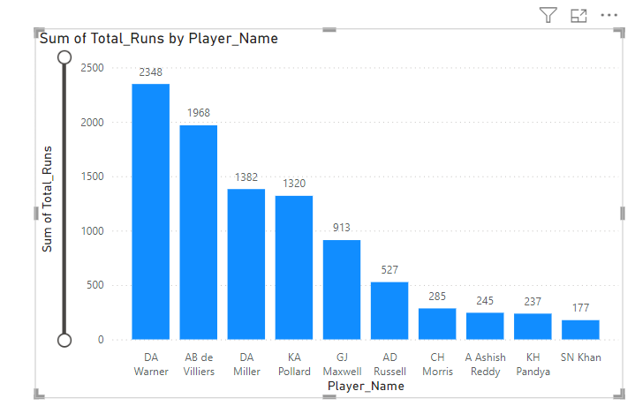

**DA Warner (2348 runs)**, **AB de Villiers (1966 runs)**, and **DA Miller (1382 runs)** lead in total runs scored. These players are consistent performers who can be relied upon to build or chase totals, positively influencing team performance.

**Impact on Team Performance**:

* Consistent run-scorers provide stability to the batting lineup, allowing other players to play more freely. Their presence in the team reduces pressure on others and increases the overall confidence within the squad.

**Recommendation:** These players not only contribute heavily to the team's scoreboard but also bring experience and composure, which are critical during high-pressure situations. Their performances often set the tone for the rest of the team, leading to better overall team performance.

In summary, players who score heavily and at a fast pace, such as Warner, de Villiers, and Miller, are key to lifting both the morale and performance of the team. Their ability to consistently deliver impactful performances makes them invaluable assets to any squad.

1. **What would you suggest to RCB before going to mega auction ?**

**Ans:** **Bidding Tactics:**

**Early Bids vs. Late Bids:**

* **Early Bids:** Placing bids early can secure key players before the competition increases. This strategy is effective for players who are expected to attract high bids.
* **Late Bids:** Waiting until the later stages can help in securing players at potentially lower prices as budget constraints come into play for other teams. This can be effective for under-the-radar or less popular players.

**Targeting Uncapped Players:**

Focusing on uncapped players can be cost-effective. These players often have high potential and can be game-changers. They are typically less expensive and provide great value for money.

**Risk Management:**

**Backup Options:**

* Always have alternative choices for each position. If primary targets are outbid, having a list of secondary options ensures the team can still build a balanced squad without overspending.

**Contingency Plans for Injuries:**

* Prepare for the possibility of injuries by selecting versatile players who can fill multiple roles. Having a well-thought-out plan for replacement players helps maintain team strength and performance levels.

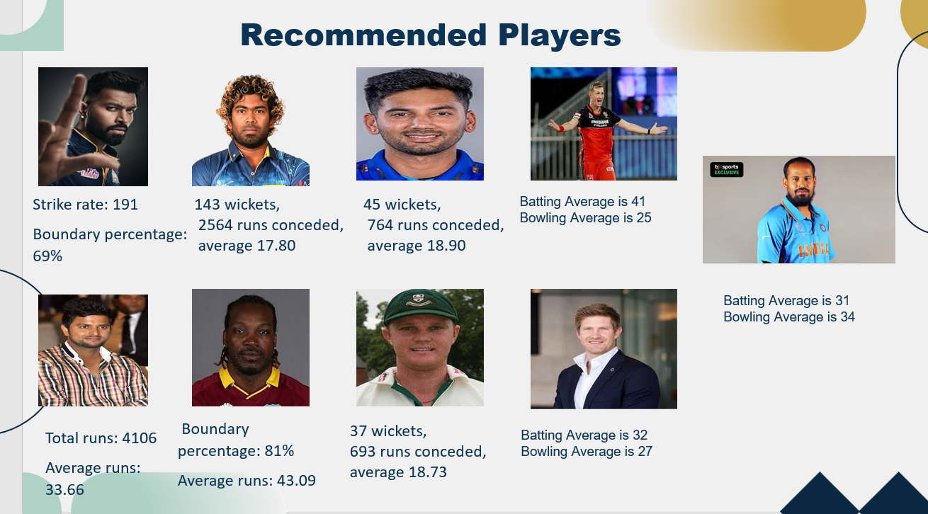

1. **What do you think could be the factors contributing to the high-scoring matches and the impact on viewership and team strategies**

**Ans:** 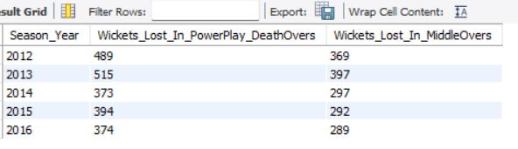

**Query:**

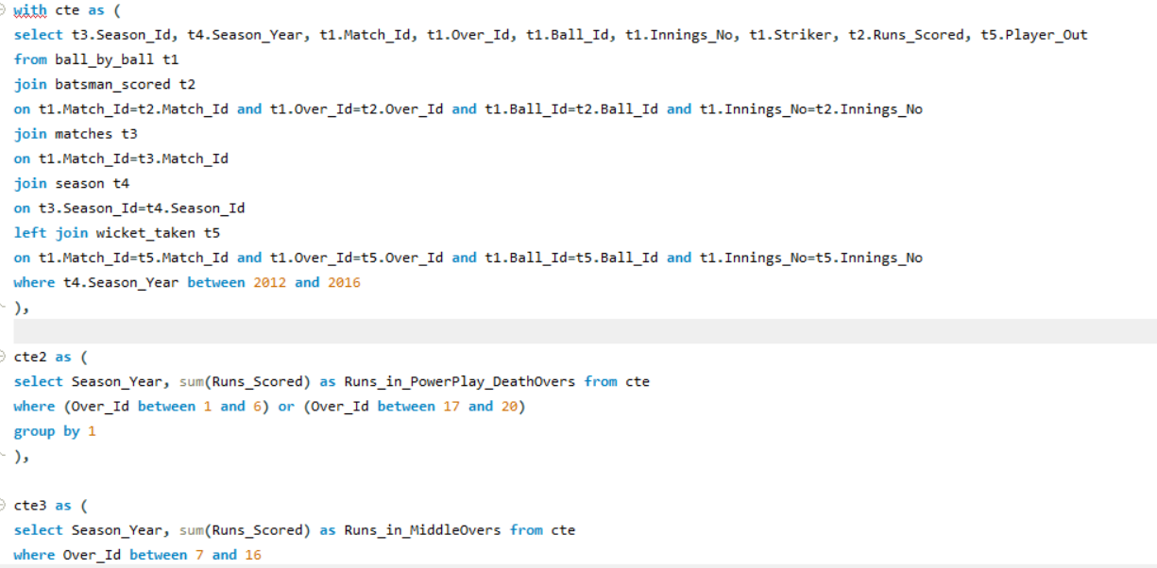

1. **Aggressive Batting Strategies**:
   * **PowerPlay**: Teams tend to score quickly, leading to more wickets.
   * **Death Overs**: Batsmen often take higher risks to maximize the score, resulting in more dismissals.
2. **Pitch and Ground Conditions**: Favorable conditions for batting can lead to higher scores and increased wicket losses during aggressive phases.
3. **Bowling Quality**: Inconsistent or ineffective bowling attacks can contribute to higher scores and more wickets in key overs.

**Recommendation**:

* **Viewership**: High-scoring matches with frequent boundaries and wickets tend to be more exciting, potentially increasing viewership.
* **Team Strategies**: Teams may focus on strengthening their death-over batting and bowling strategies, selecting players known for their performance in these crucial phases during auctions.

1. **Analyze the impact of home ground advantage on team performance and identify strategies to maximize this advantage for RCB.**

**Ans:**

#### Impact of Home Ground Advantage:

1. **Familiarity with Pitch Conditions**: Players are more accustomed to the pitch behaviour and ground dimensions.
2. **Crowd Support**: Home crowd support can boost player morale and performance.
3. **Tailored Strategies**: Teams can optimize their strategies based on the specific characteristics of their home ground.

#### Strategies to Maximize Home Ground Advantage:

1. **Specialized Training**: Conduct regular practice sessions focusing on the unique aspects of the home pitch.
2. **Player Selection**: Choose players who perform well in home conditions.
3. **Fan Engagement**: Enhance fan experience to maintain strong crowd support.
4. **Adaptation to Pitch**: Develop strategies that leverage the specific pitch characteristics, such as focusing on spin or pace based on the ground’s history.

| **Result** | **Count** | **Percentage** |
| --- | --- | --- |
| Won | 29 | 53.7% |
| Lost | 25 | 46.3% |

**Recommendation:** RCB's home ground advantage is evident with a win rate of 53.7%, driven by familiarity with pitch conditions, crowd support, and tailored strategies. To further maximize this advantage, RCB should focus on specialized training, selecting players suited to home conditions, engaging fans, and developing strategies that exploit the unique characteristics of their home pitch. These steps could enhance their overall home performance and contribute to greater success in future seasons.

1. **Come up with a visual and analytical analysis with the RCB past seasons performance and potential reasons for them not winning a trophy.**

* **Total Scores**: only is 1st season the team scored less. And in the past season the team score is good, actually we can say the performance of batsman is consistently good.
* **Total Wickets**: the highest number of wickets were taken in 2015.. so we can say that the bowlers are also playing good.
* **Performance Status**: The overall performance status is consistent.
* **Potential Reasons for Not Winning a Trophy**:

1. **Inconsistent Performance**:
   * Fluctuations in total scores and wickets lost suggest inconsistency in performance, which can impact crucial matches.
2. **Key Matches Losses**:
   * Losing key matches, especially during playoffs, can significantly affect the chances of winning a trophy.
3. **Dependence on Star Players**:
   * Over-reliance on a few star players can be detrimental if they underperform or are unavailable.
4. **Injury Concerns**:
   * Frequent injuries to key players can disrupt team balance and performance.
5. **Strategic Decisions**:
   * Ineffective strategies, such as poor team selection or suboptimal batting/bowling orders, can impact outcomes.

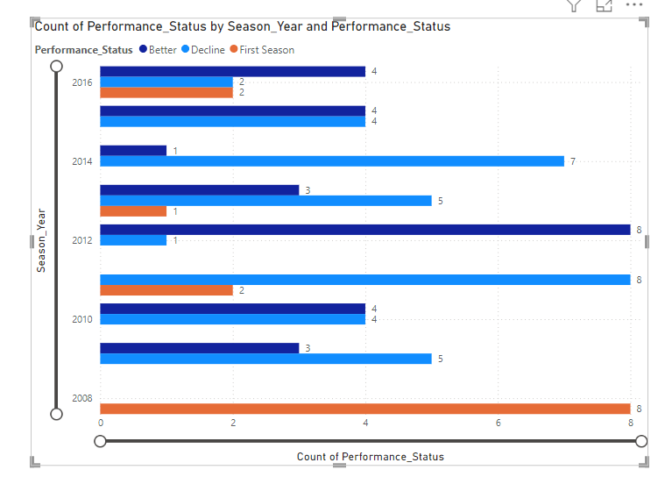

**Recommendation**: Despite consistently strong performances in both batting and bowling, RCB has not won a trophy due to several underlying issues. These include inconsistent performances in crucial matches, over-reliance on star players, injuries to key players, and occasionally ineffective strategic decisions. While the team has shown potential, these factors have likely contributed to their inability to secure a championship victory. Addressing these areas could improve their chances of winning in future seasons**.**

1. **How would you approach this problem, if the objective and subjective questions weren't given?**

* **Ans:**
* **Team Balance**: Strive to form a well-rounded team that includes a blend of batsmen, bowlers, all-rounders, and wicketkeepers.
* **Role-Specific Requirements**: Pinpoint the specific roles that need strengthening, such as power hitters, finishers, death bowlers, spinners, and more.
* **Budget Optimization**: Strategically manage the available budget to enhance team strength without surpassing the salary cap.
* **Objective Criteria**:
  + **Batting**: Assess based on average, strike rate, consistency, and ability to perform under pressure.
  + **Bowling**: Evaluate economy rate, strike rate, wicket-taking ability, and performance across different phases (powerplay, middle overs, death overs).
  + **Fielding**: Look at the number of catches, run-outs, and overall agility.
  + **All-Round Ability**: Consider contributions with both bat and ball.
* **Subjective Criteria**:
  + **Current Form**: Review recent performances in domestic and international cricket.
  + **Injury History**: Check fitness and injury records.
  + **Team Fit**: Assess the player's ability to integrate with the existing squad and team culture.
  + **Leadership and Experience**: Look for experience in high-pressure situations and potential for leadership roles.

**Recommendation**: If objective and subjective questions weren't provided, the approach to team building would involve focusing on **team balance**, identifying **role-specific needs**, and optimizing the **budget**. Objective criteria like batting and bowling stats, fielding performance, and all-round ability would guide player selection, while subjective criteria such as current form, injury history, team fit, and leadership potential would refine the choices. This comprehensive strategy ensures a well-rounded and effective squad.

1. **In the "Match" table, some entries in the "Opponent_Team" column are incorrectly spelled as "Delhi_Capitals" instead of "Delhi_Daredevils". Write an SQL query to replace all occurrences of "Delhi_Capitals" with "Delhi_Daredevils".**

**Ans:** 1.In the given IPL Dataset there is no such column name i.e "Opponent_Team" is Present.

* 2.So their will be no scope to replace the name in match table.

By :: Select * from Match;

* But in the team table there are two columns Team_Id and Team_name
* we get team name here we can change the team name from
* "Delhi_Capitals" to "Delhi_Daredevils".
* By:: **select**
* **Team_Id, replace(Team_name,"Delhi_Capitals","Delhi_Daredevils") as Team_name from team;**

